1. **BIT SABAN-2000008008-Saving Account for Loan(Int)**

Saving Accoung for Loan show minus (-95.91) on Saving Listing:

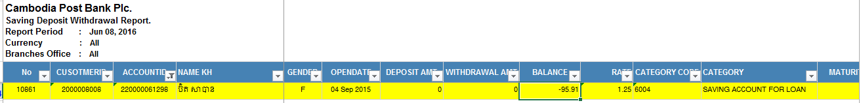

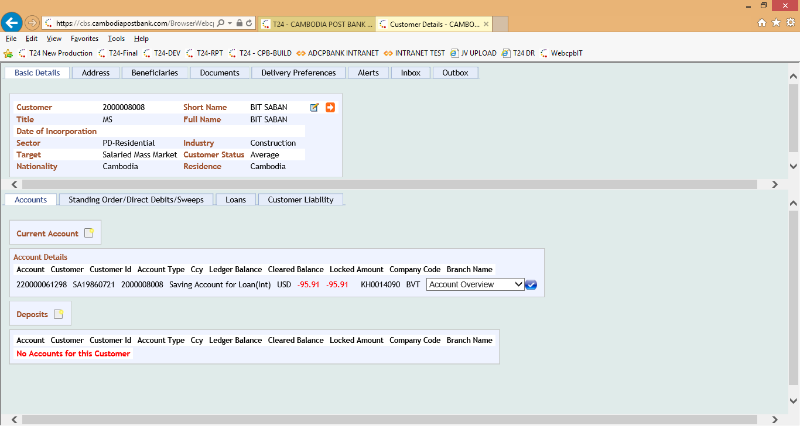

**220000061298**

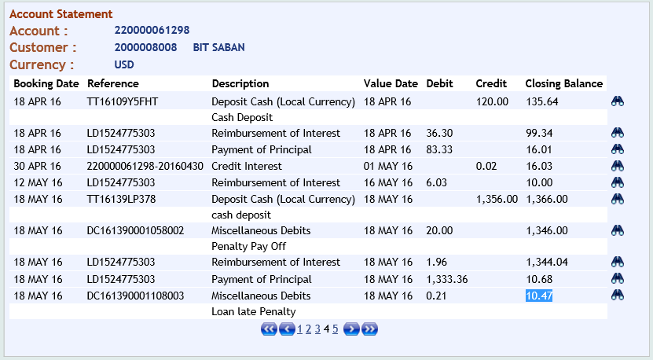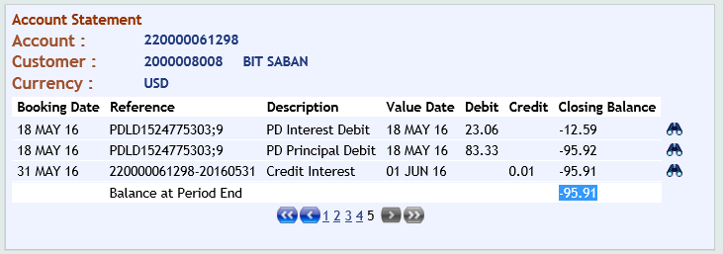

**PDLD1524775303**

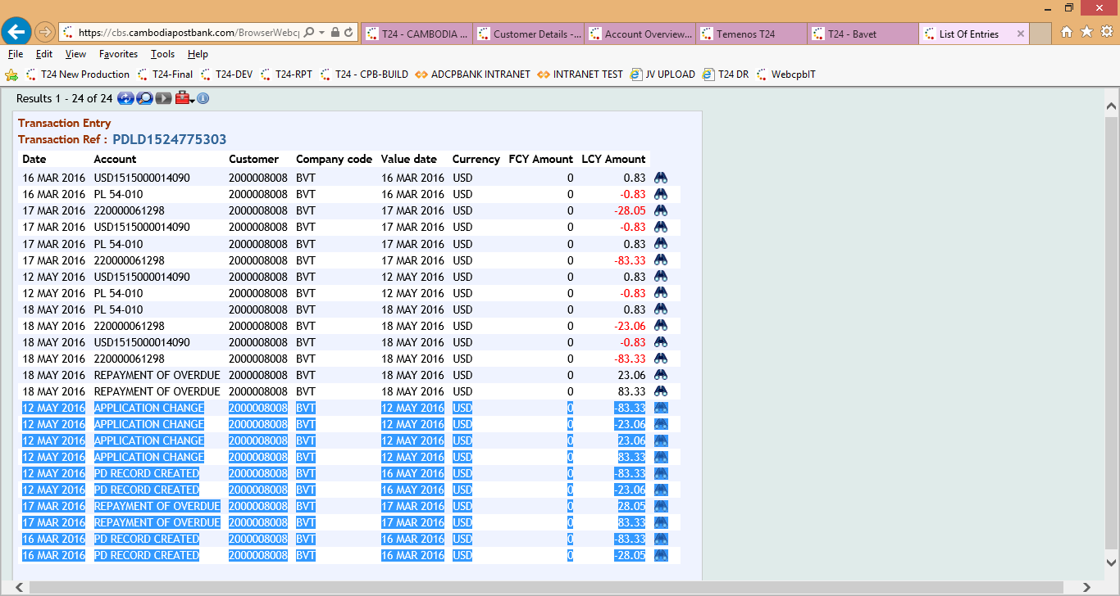

LD1524775303

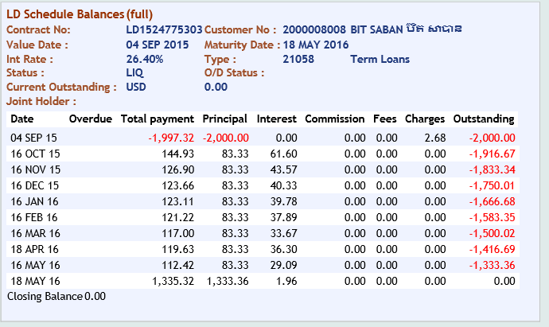

1. **BUN SOPHEAP- 4000009959- Fixed Deposit-SEMM**

The Saving Report Listing cannot show **Int. Rate**, **Maturity Date** and **Pay Account**.

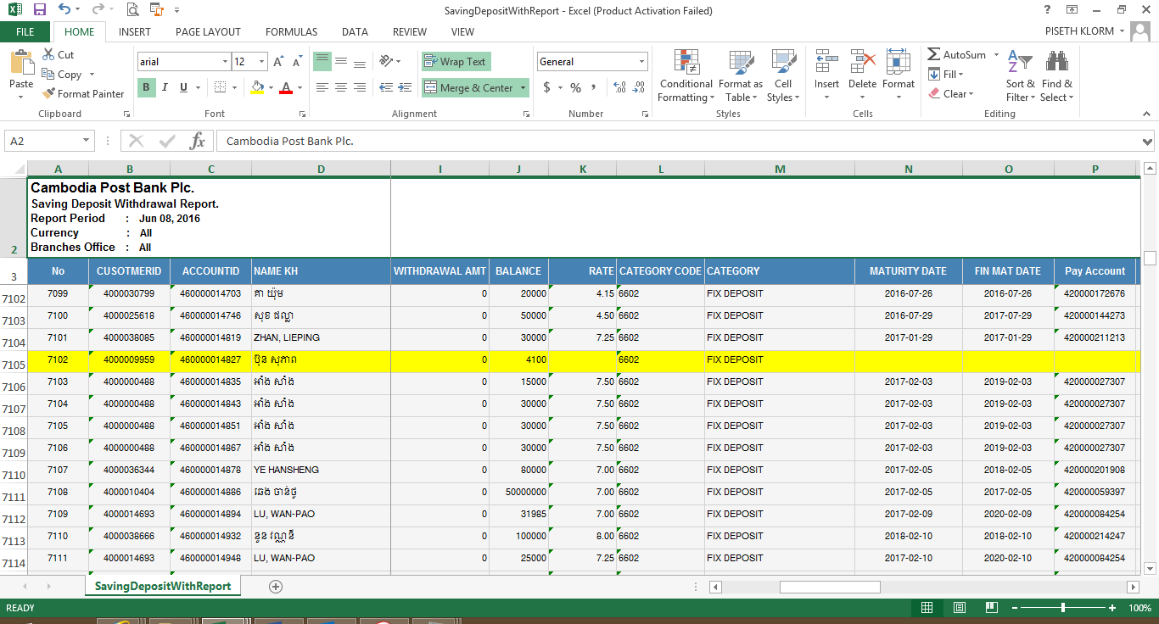

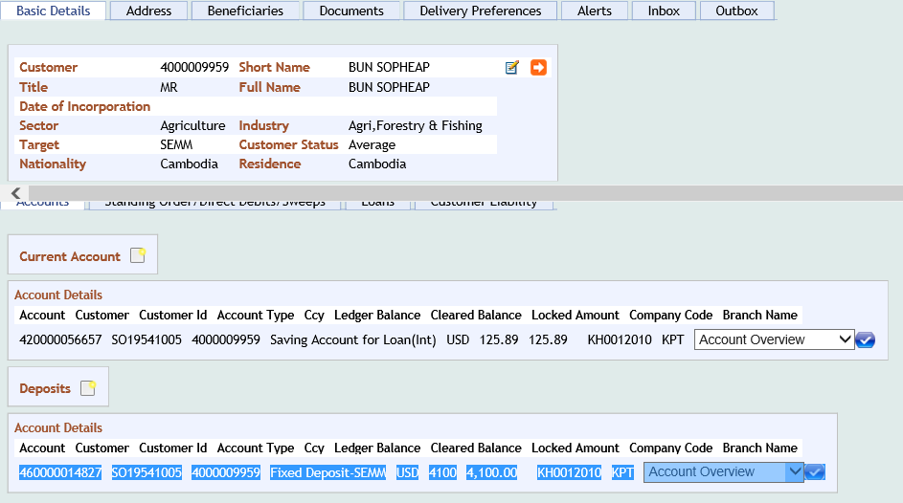

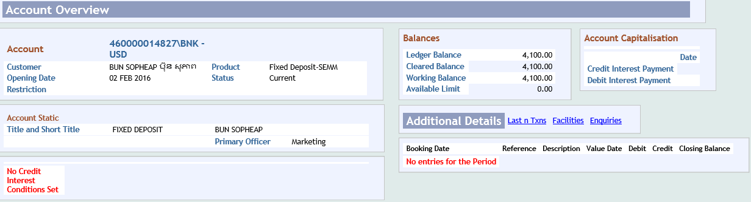

**Account Statement-460000014827**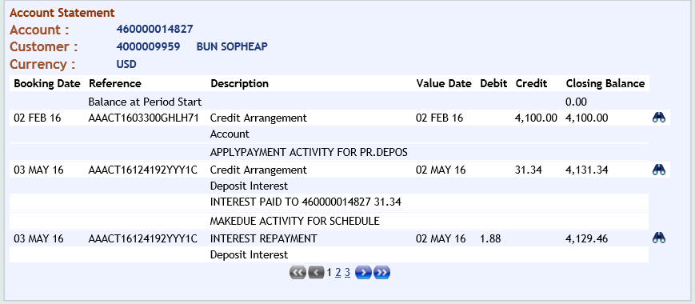 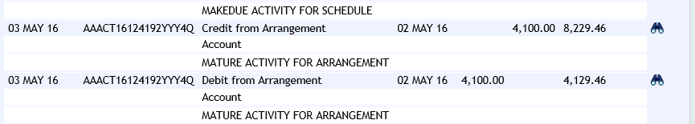 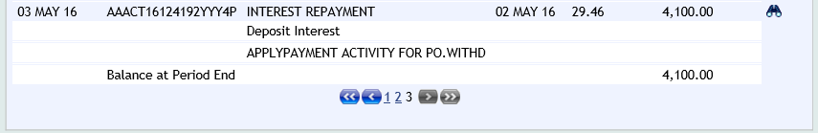

1. **MUON BUNHAK-** **4000016429**

**AIR** of Loan Outstanding is Error with Loan Listing (on 31-May-2016):

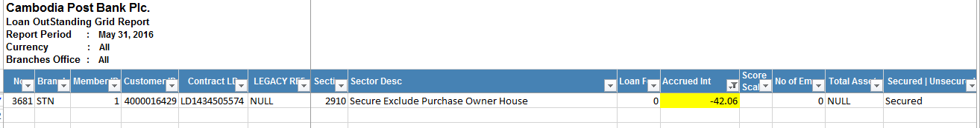

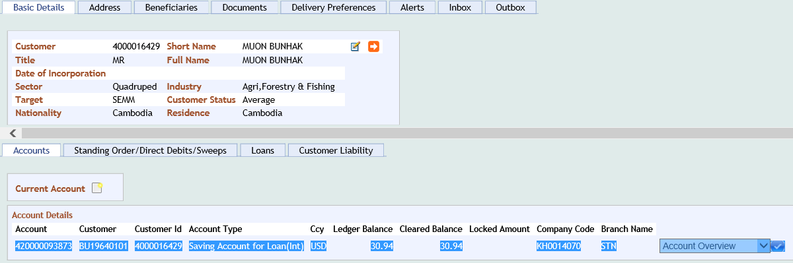

**420000093873**

152370-Doubtful Loans – Other Long term Loans Private Sector - Resident

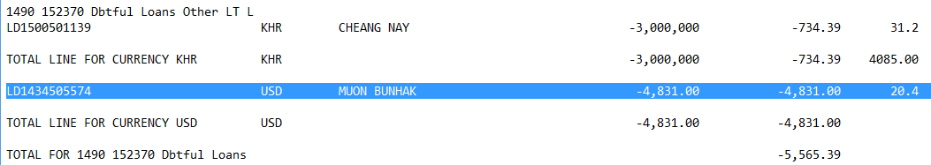

272370-AIR – Doubtful Loans – Other Long term Loans - Private Sector - Resident

